**PROGRAMS:**

1. **Print “C++ is better than C” and use comments.**

**Input:**

#include<iostream>

#include<conio.h>

using namespace std;

int main()

{

cout << "C++ is better than C";

_getch();

}

**Output:**

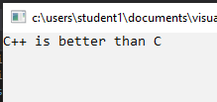

1. **Find the sum and average of two numbers.**

**Input:**

#include<iostream>

#include<conio.h>

using namespace std;

int main(){

int num1, num2;

cout << "Enter value of Number 1 : ";

cin >> num1;

cout << "Enter value of Number 2 : ";

cin >> num2;

cout << "Sum : " << num1 + num2;

cout << "\nAverage : " << (num1 + num2) / 2;

_getch();

}

**Output:**

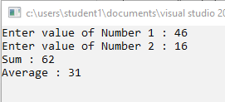

1. **Even & Odd numbers**

**Input:**

#include<iostream>

#include<conio.h>

using namespace std;

int main()

{

int num;

cout << "Enter the Number : ";

cin >> num;

if (num % 2)

cout << "Given number is Odd";

else

cout << "Given number is Even";

_getch();

}

**Output:**

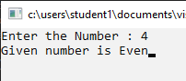

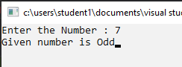

1. **Quadratic Equations**

**Input:**

#include<iostream>

#include<conio.h>

#include<math.h>

using namespace std;

int main()

{

int a, b, c, d = 0 , r1, r2;

cout << "Enter the coefficient for the quadratic equation: \n";

cin >> a >> b >> c;

d = sqrt((b * b) - (4 * a * c));

r1 = ((-1 * b) + d) / (2 * a);

r2 = ((-1 * b) - d) / (2 * a);

cout << "\n1st root : "<< r1;

cout << "\n2st root : " << r2 ;

_getch();

}

**Output:**

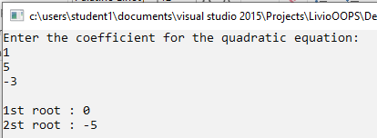

1. **Factorial number**

**Input:**

#include<iostream>

#include<conio.h>

using namespace std;

int main()

{

int num, i, fact = 1;

cout << "Enter the number to find it's Factorial: ";

cin >> num;

if (num == 0 || num == 1)

fact = 1;

else

for (i = 1;i <= num;i++)

fact *= i;

cout << "\nFactorial :" << fact;

_getch();

}

**Output:**

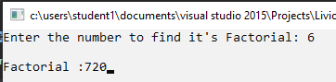

1. **Fibonacci of number**

**Input:**

#include<iostream>

#include<conio.h>

using namespace std;

int main()

{

int term1 = 0, term2 = 1, term3, num, i;

cout << "Enter the number of terms: ";

cin >> num;

if (num == 1)

cout << "Fibonacci series: " << term1;

else if (num == 2)

cout << "Fibonacci series: " << term1 << "\t" << term2;

else

{

cout << "Fibonacci series: " << term1 << "\t" << term2;

for (i = 2; i < num; i++)

{

term3 = term1 + term2;

term1 = term2;

term2 = term3;

cout << "\t" << term3;

}

}

_getch();

}

**Output:**

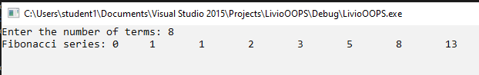

1. **Fibonacci of number**

**Input:**

#include<iostream>

#include<conio.h>

using namespace std;

int main()

{

int r;

float area;

cout << "Enter the radius : ";

cin >> r;

area = 3.14 * r * r;

cout << "Area: " << area;

_getch();

}

**Output:**

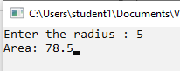

1. **Find the Sum of elements of an array.**

**Input:**

#include<iostream>

#include<conio.h>

using namespace std;

int main()

{

int i, arr[20], size, sum = 0;

cout << "Enter the number of elements :";

cin >> size;

cout << "Enter the elements\n";

for (i = 0;i < size;i++)

cin >> arr[i];

for (i = 0;i < size;i++)

sum += arr[i];

cout << "Sum : " << sum;

_getch();

}

**Output:**

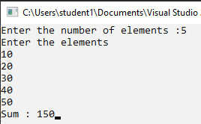

1. **Find largest element of an array.**

**Input:**

#include<iostream>

#include<conio.h>

using namespace std;

int main()

{

int i, arr[20], size, max;

cout << "Enter the number of elements :";

cin >> size;

cout << "Enter the elements\n";

for (i = 0;i < size;i++)

cin >> arr[i];

max = arr[0];

for (i = 0;i < size;i++)

{

if (max < arr[i])

{

max = arr[i];

}

}

cout << "Largest : " << max;

_getch();

}

**Output:**

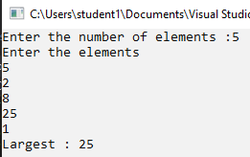

1. **Implement default arguments.**

**Input:**

#include <iostream>

using namespace std;

int fn(int a = 10, int b = 20, int c = 30)

{

    int sum;

    sum = a + b + c;

    return (sum);

}

int main()

{

    cout << "Without Arguments" << endl;

    cout << "Sum : " << fn() << endl;

    cout << "One Arguments" << endl;

    cout << "Sum : " << fn(65) << endl;

    cout << "Two Arguments" << endl;

    cout << "Sum : " << fn(65, 30) << endl;

    cout << "Three Arguments" << endl;

    cout << "Sum : " << fn(65, 30, 8) << endl;

    return 0;

}

**Output:**

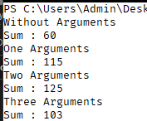

1. **Add, subtract, multiply and divide two numbers using inline functions**

**Input:**

#include <iostream>

using namespace std;

inline int add(int a, int b){

    return a + b;

}

inline int sub(int a, int b){

    return a - b;

}

inline int mul(int a, int b){

    return a * b;

}

inline float divide(int a, int b){

    return a / b;

}

int main(){

    int a, b, choice;

    while (1){

        cout << "\n1. Addition \n2. Subtraction \n3. Multiplication \n4. Division \n5.Exit\n";

        cin >> choice;

        switch (choice){

        case 1:

            cout << "Enter the number\n";

            cin >> a >> b;

            cout << "Sum :" << add(a, b);

            break;

        case 2:

            cout << "Enter the number\n";

            cin >> a >> b;

            cout << "Difference :" << sub(a, b);

            break;

        case 3:

            cout << "Enter the number\n";

            cin >> a >> b;

            cout << "Product :" << mul(a, b);

            break;

        case 4:

            cout << "Enter the number\n";

            cin >> a >> b;

            cout << "Quentient :" << divide(a, b);

            break;

        case 5:

            return 0;

        default:

            cout << "Invalid Input";

        }

    }

}

**Output:**

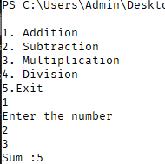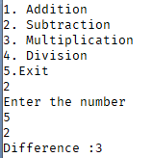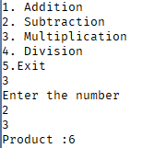

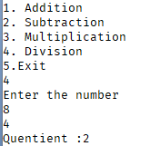

1. **Write a function to implement static variables.**

**Input:**

#include<iostream>

using namespace std;

void staticVar(){

    static int c = 0;

    cout << c++;

}

void var(){

    int c = 0;

    cout << c++;

}

int main(){

    cout<<"Static Variable : ";

    for (int i = 0; i < 5; i++)

        staticVar();

    cout<<"\nVariable : ";

    for (int i = 0; i < 5; i++)

        var();

    return 0;

}

**Output:**



1. **Using Bar Charts Display Array Data Graphically**

**Input:**

#include<iostream>

#include<conio.h>

using namespace std;

int main()

{

const int arrSize = 11;

int arr[arrSize] = { 0, 1, 0, 2, 0, 4, 0, 2, 0, 1, 0 };

cout << "Grade Distribution"<<endl;

for (int i = 0; i < arrSize; i++)

{

if (i == 0)

cout << "0 - 9\t:";

else if (i == 10)

cout << "100\t:";

else

cout << i * 10 << " - " << (i * 10) + 9 << " :";

for (int j = 0; j < arr[i]; j++)

cout << "*";

cout << endl;

}

_getch();

}

**Output:**

